# 绘制路网

## 新建路网

File→New Network

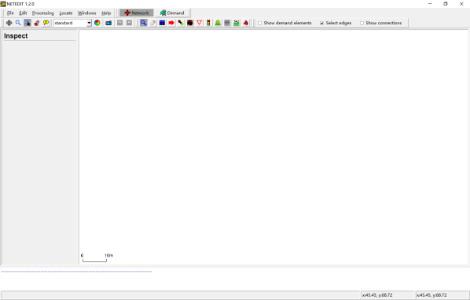

Edit菜单项

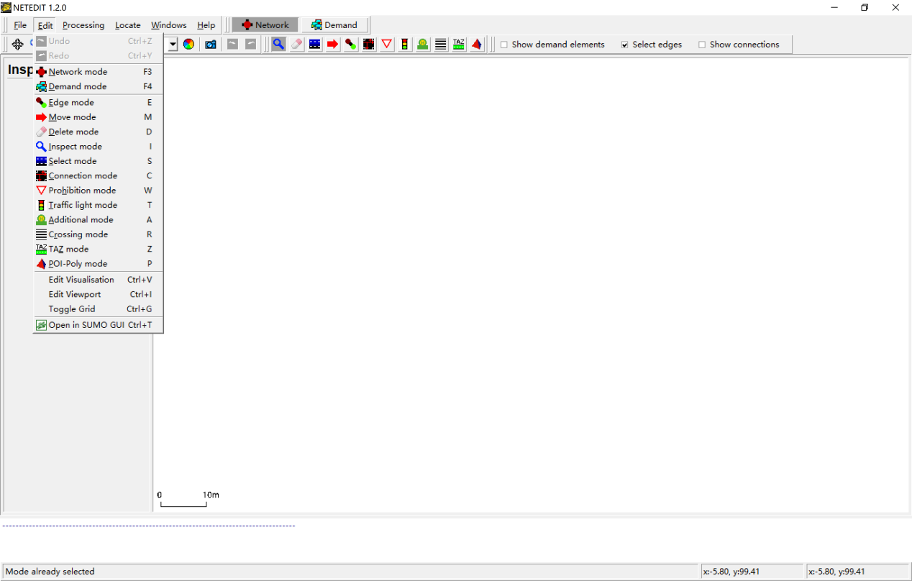

进入Edge mode：

Edit→Network mode

Edit→Edge mode

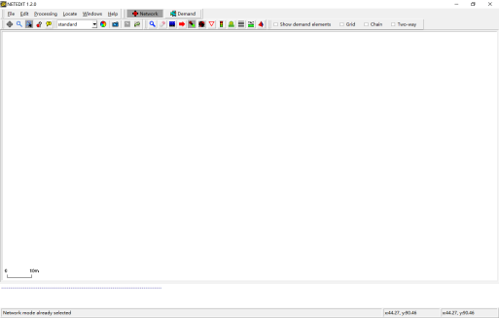

左键点击创建一个节点

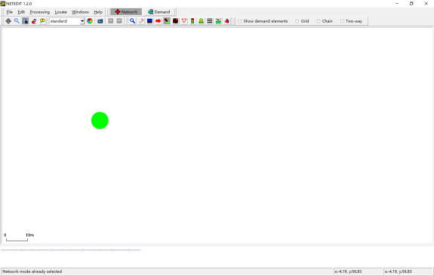

左键点击空白处，创建另一个节点，并自动生成道路

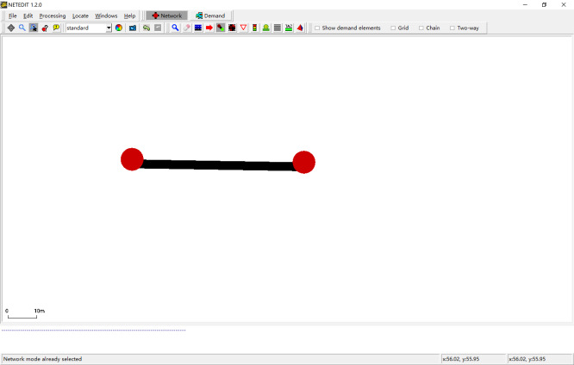

左键点击，选择一个node

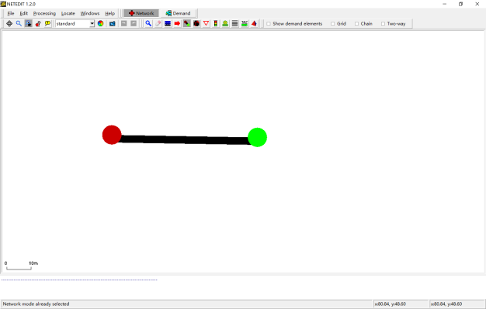

左键点击另一个node，生成对向车道

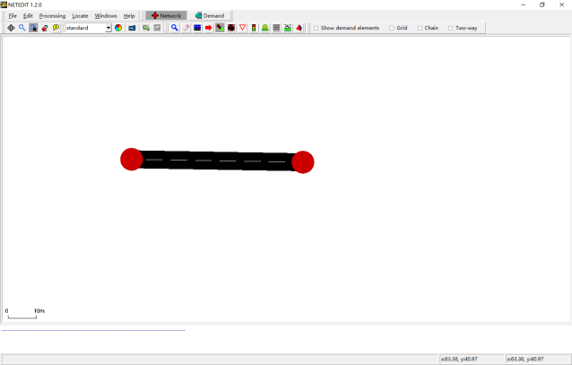

创建另外3个节点，并简单绘制一个十字交叉口

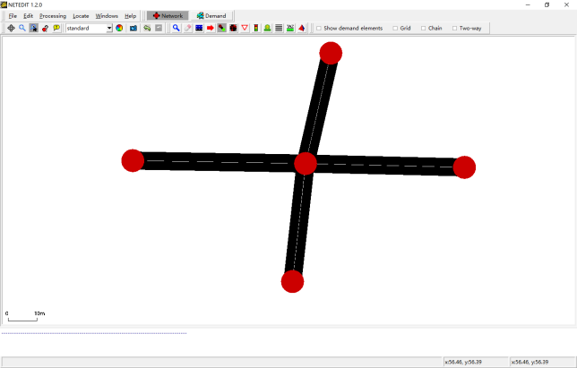

## 修改属性

进入Inspect mode：

Edit→Network mode

Edit→Inspect mode

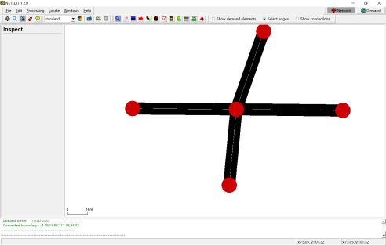

左键点击一个节点，查看信息

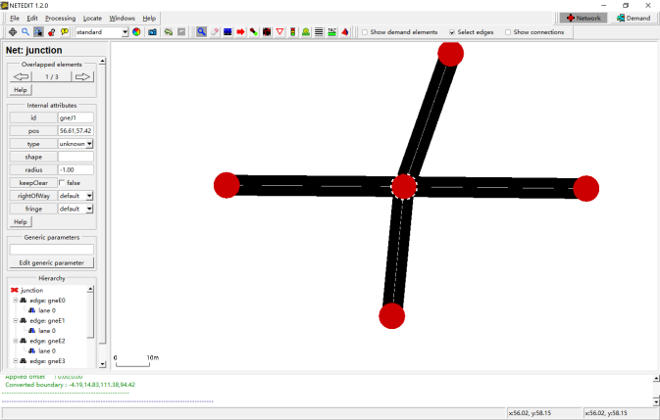

左键点击路段，查看属性

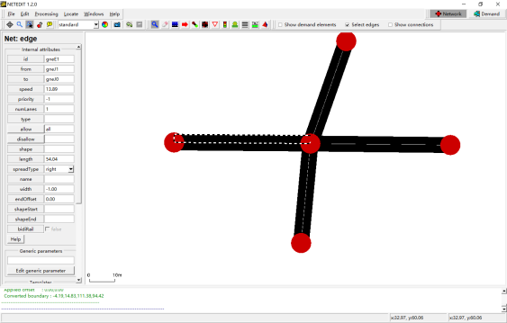

将车道数改成3，numLanes

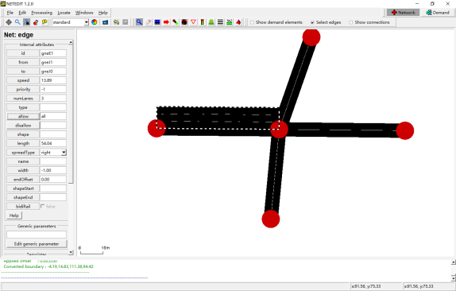

查看允许车型，点击allow，可修改

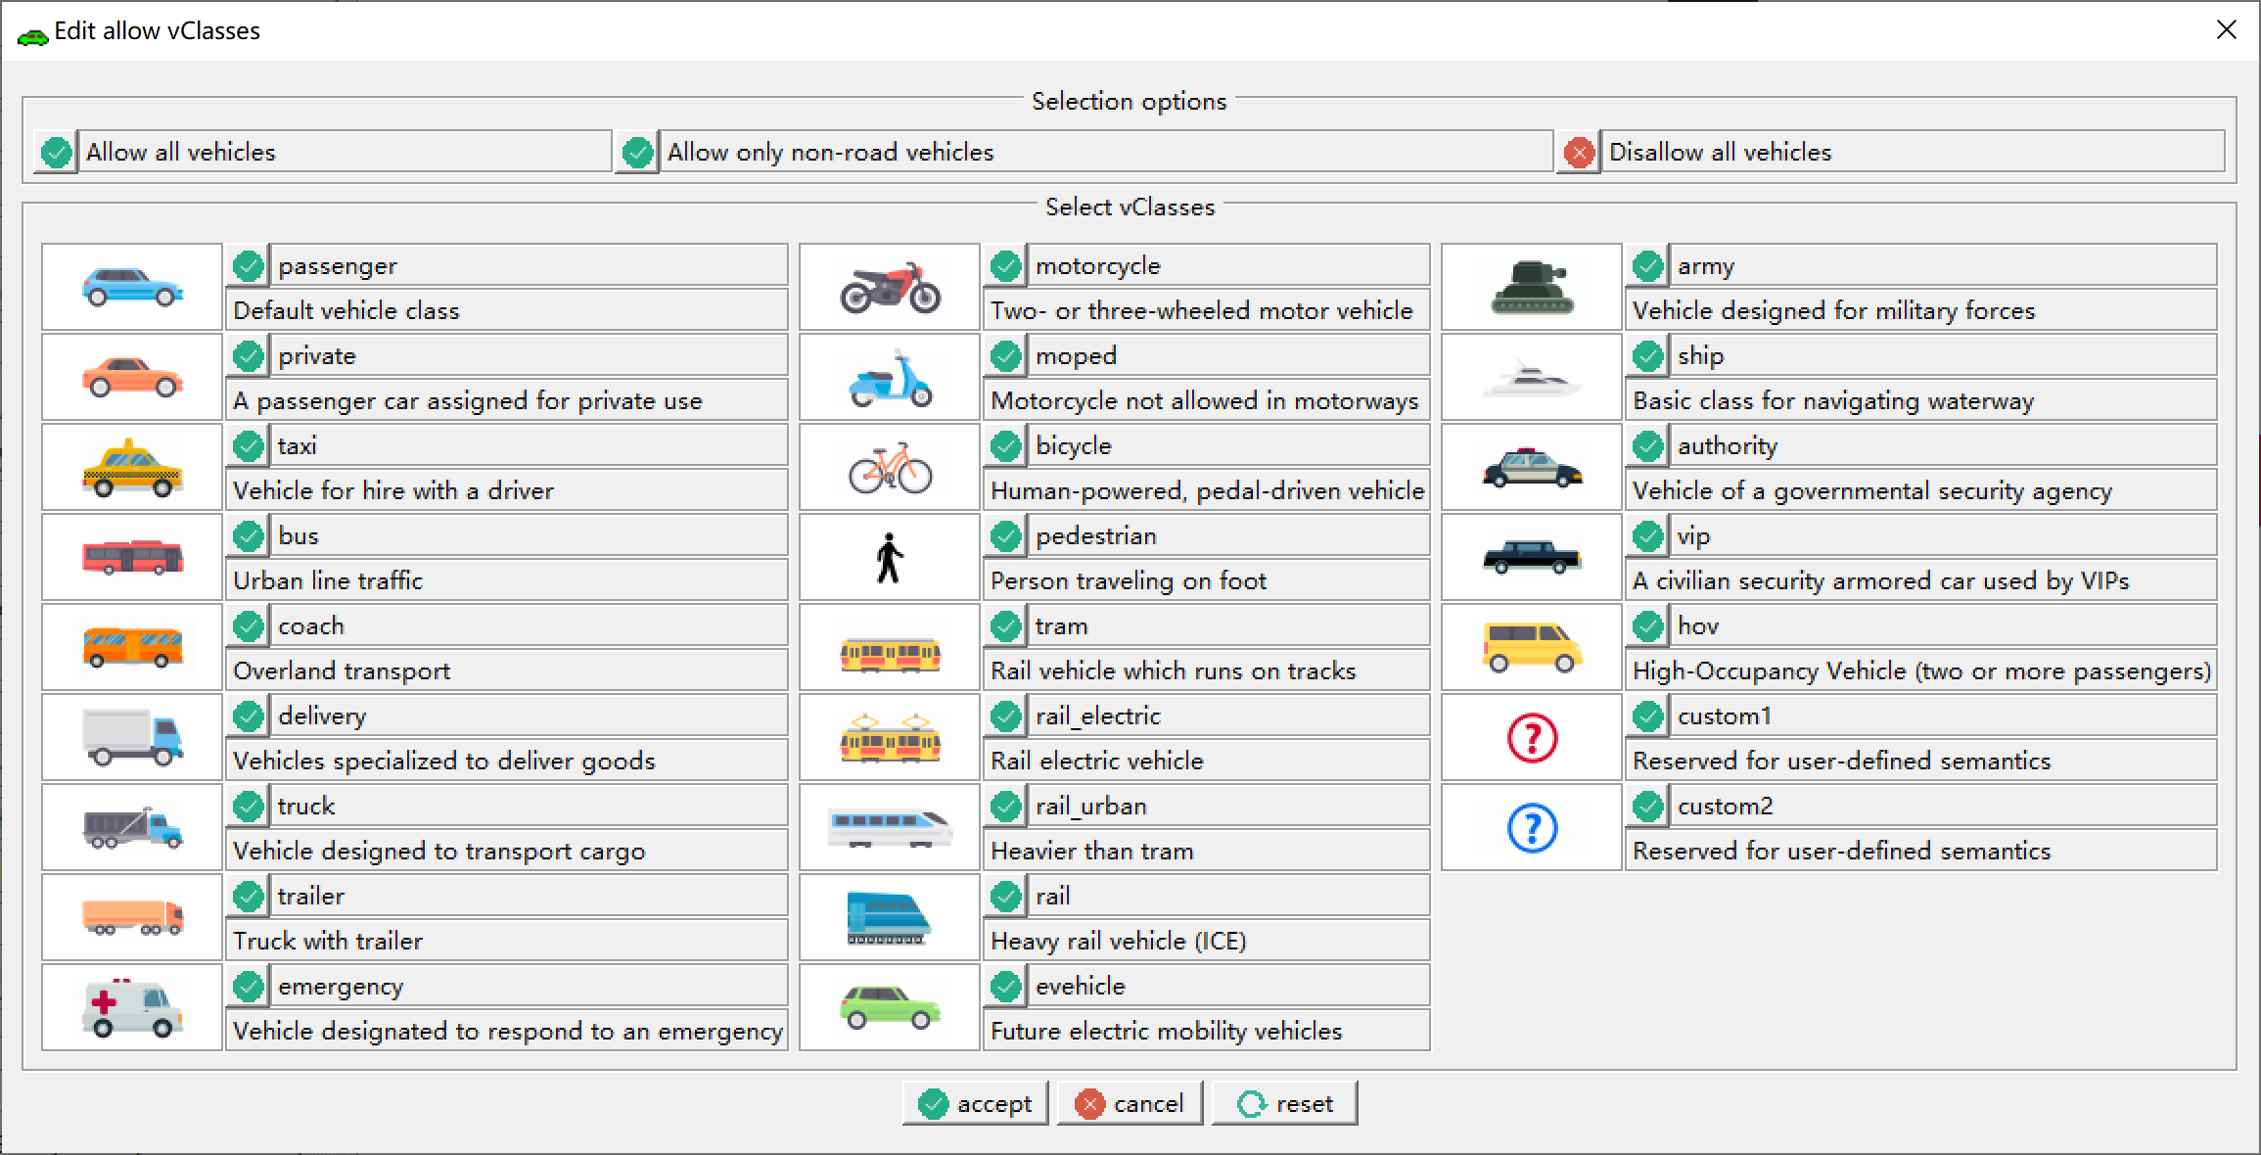

修改所有车道参数

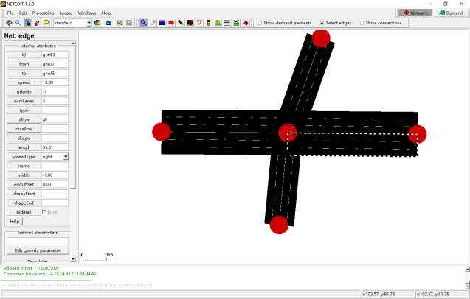

## 调整路网道路

进入Move mode：

Edit→Network mode

Edit→Move mode

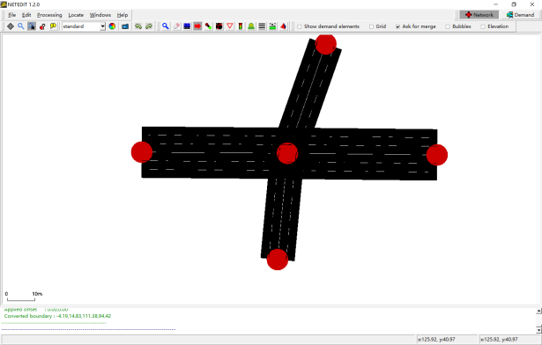

左键拖到节点到新的位置

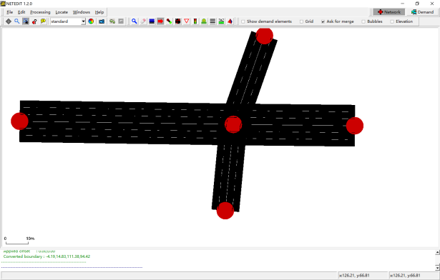

左键移动路段，改变道路几何形状

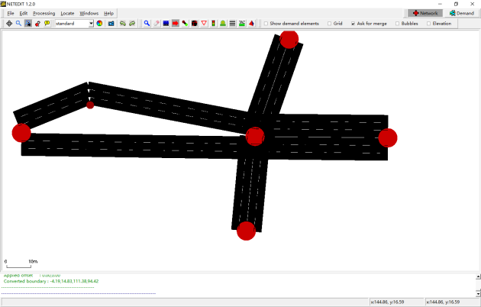

## 设置交叉口流向

进入Connection mode：

Edit→Network mode

Edit→Connection mode

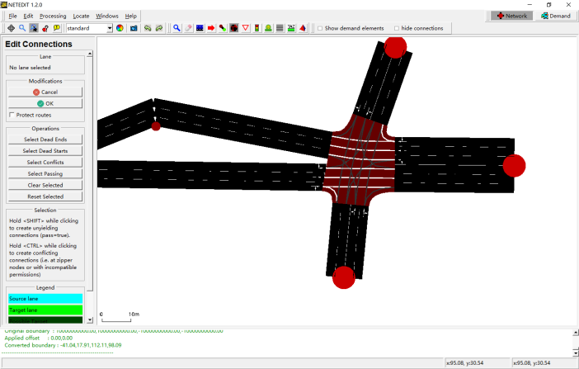

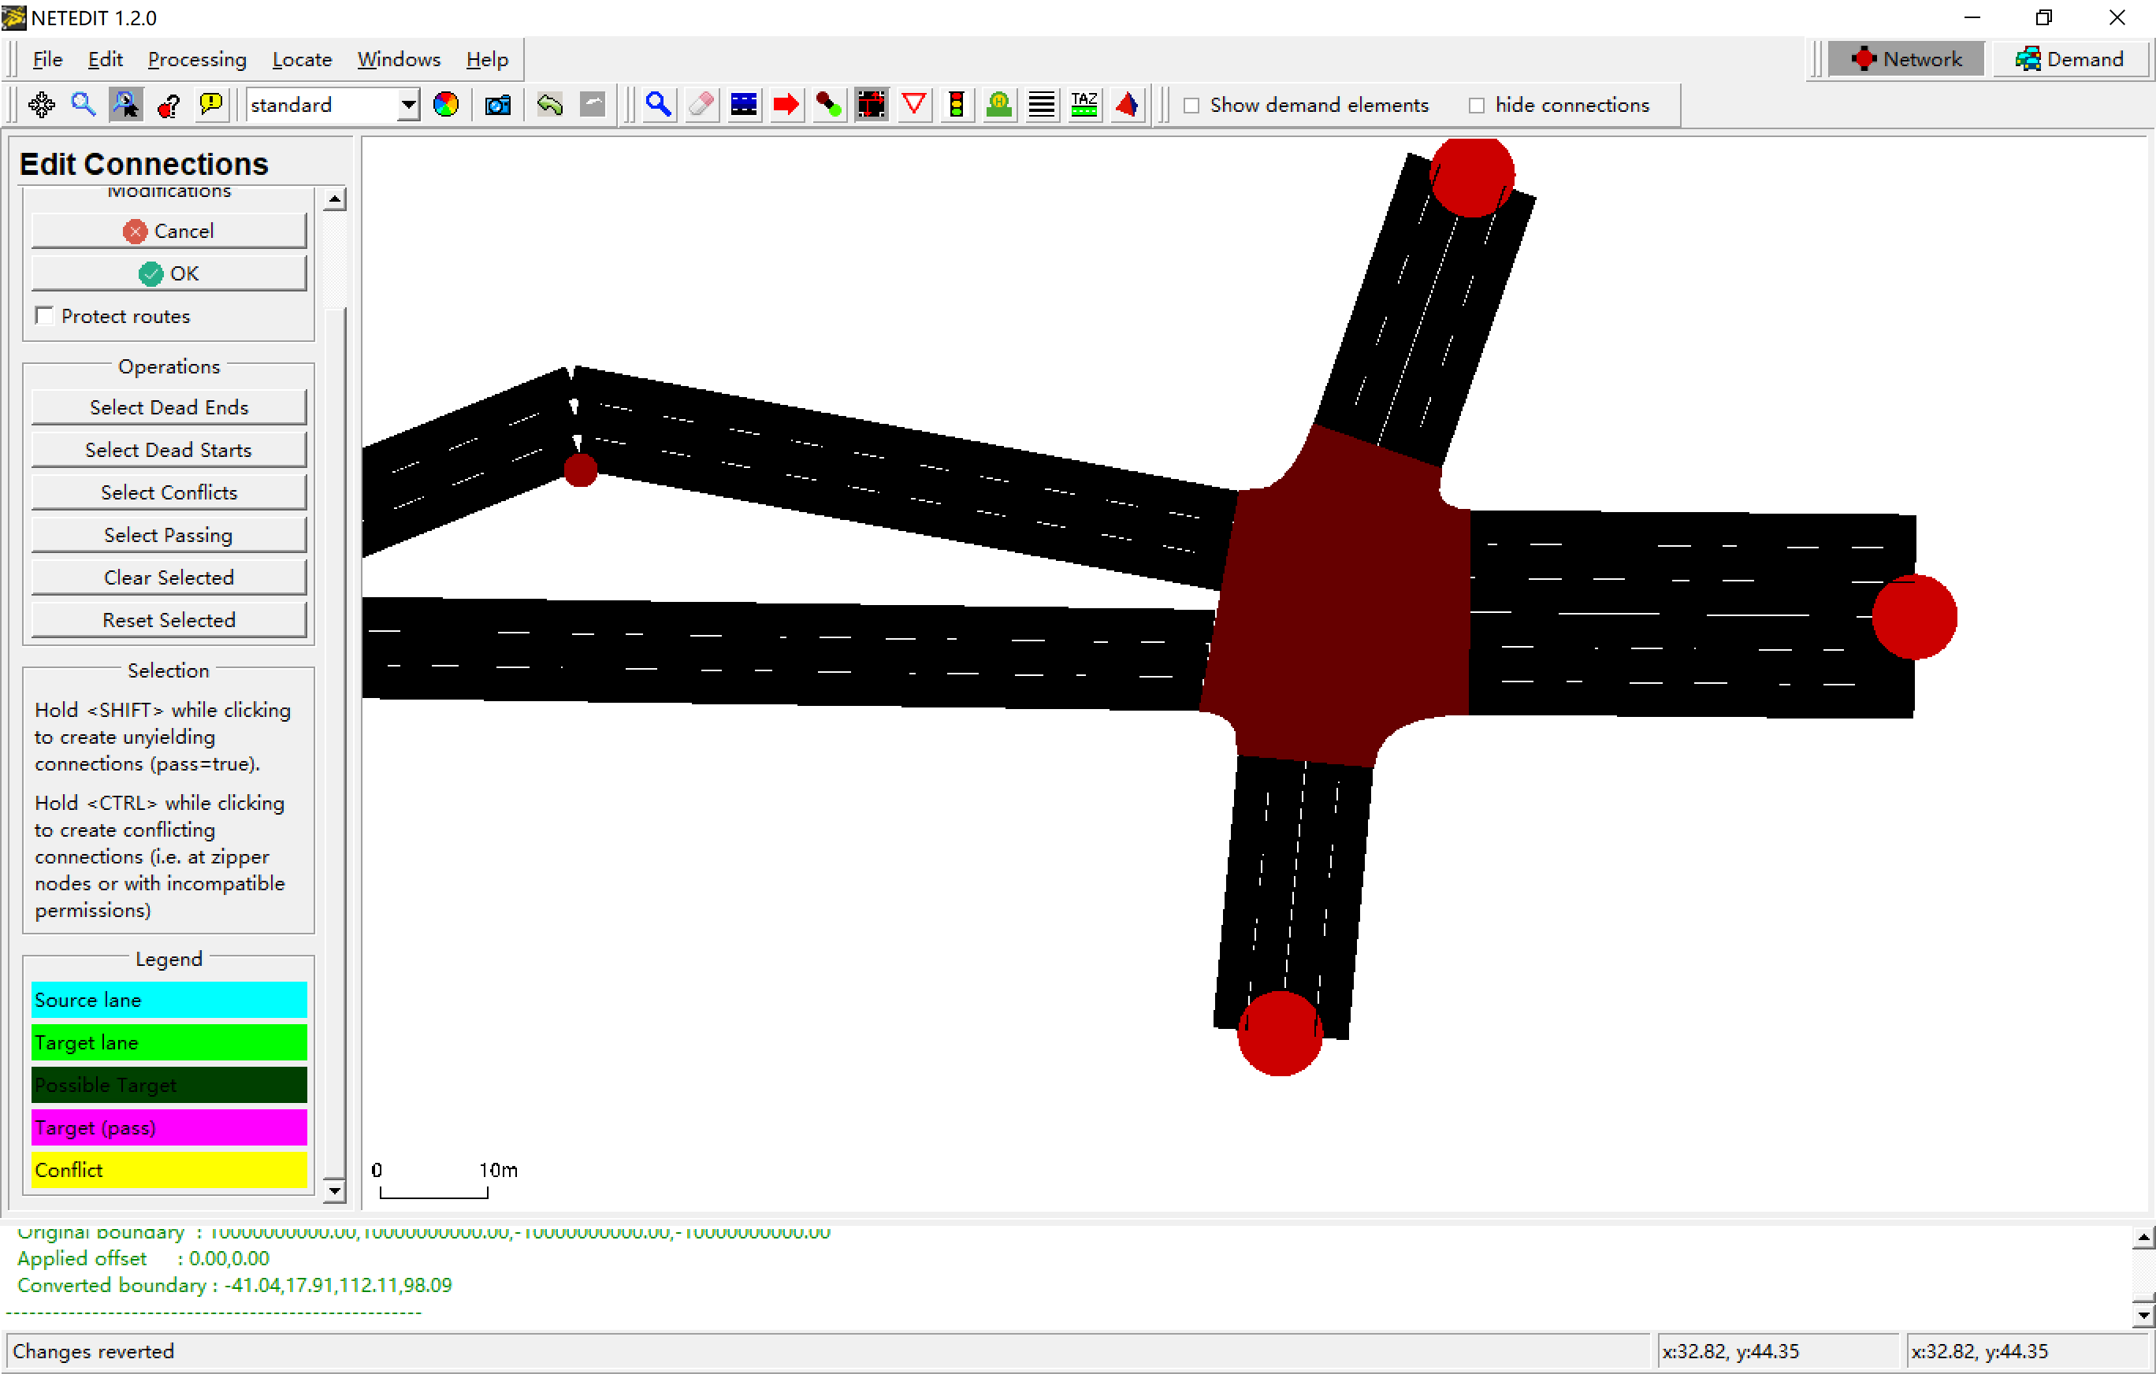

左键选择一个车道

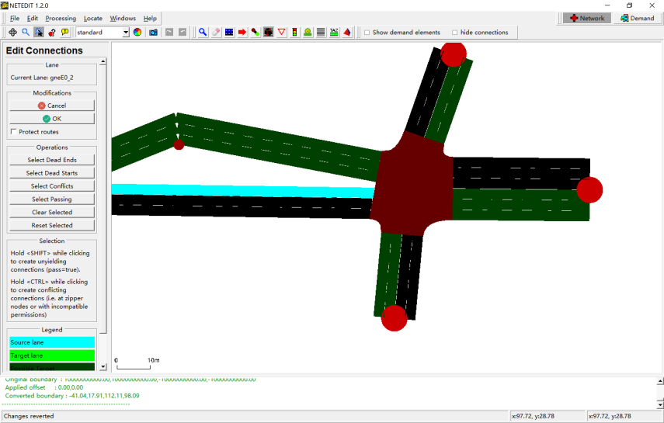

左键点击选择对应的流向车道，可多选

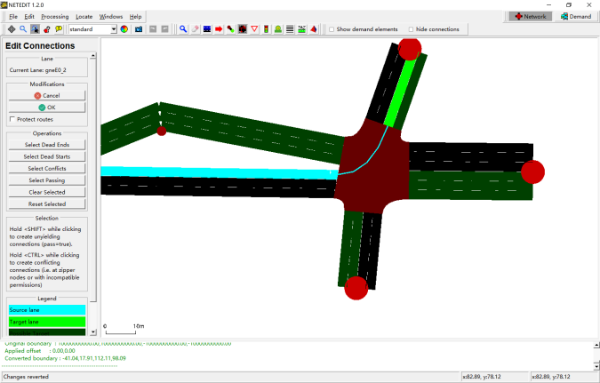

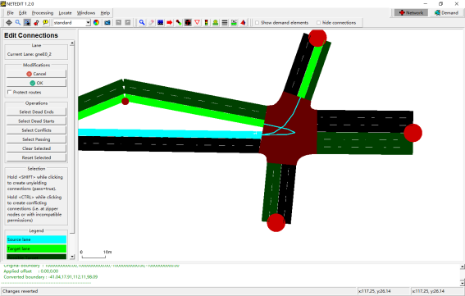

点击OK，进行下一步操作

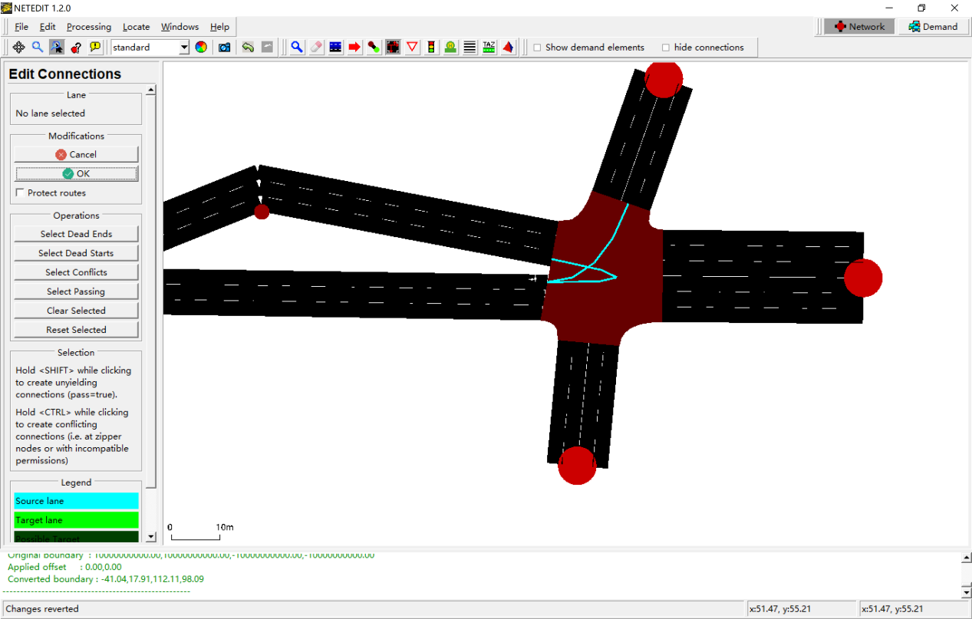

完成所有的流向设置

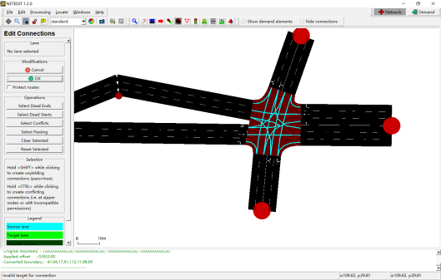

左键选择一个车道

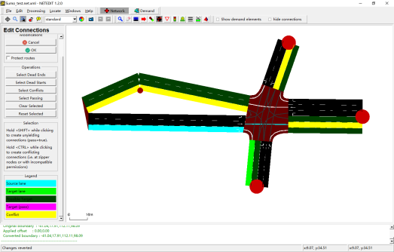

Ctrl+左键，修改冲突车道

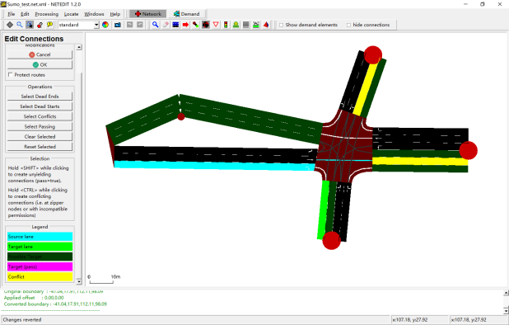

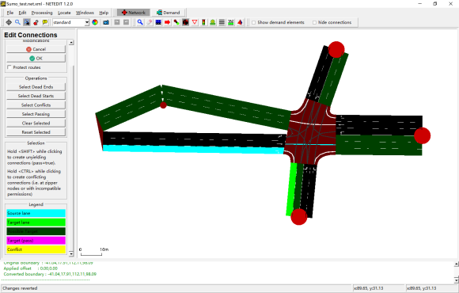

另一个车道

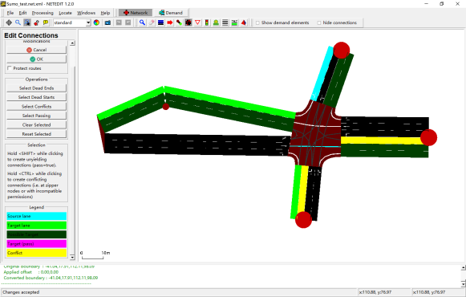

修改后

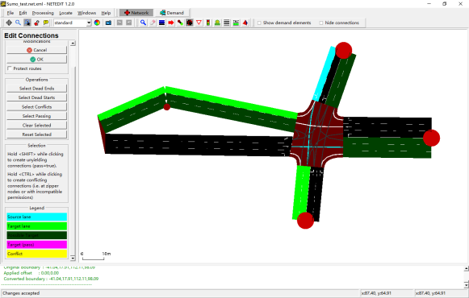

## 创建lane/storage length

创建节点

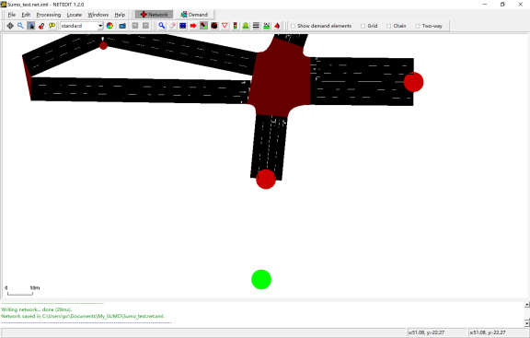

建立连接

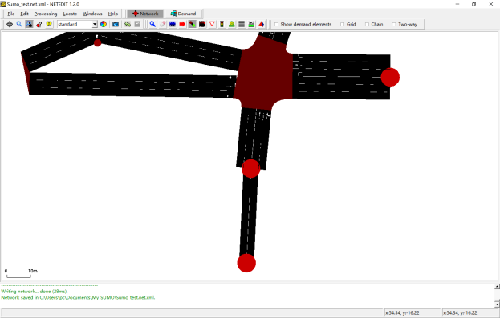

修改属性

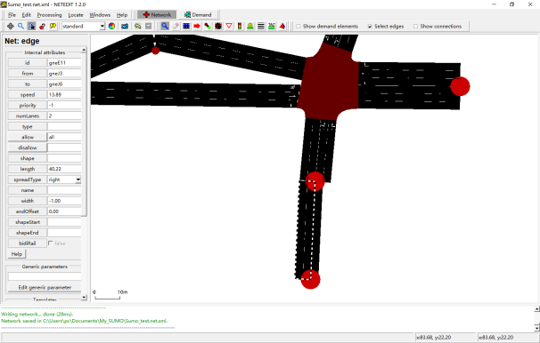

建立连接

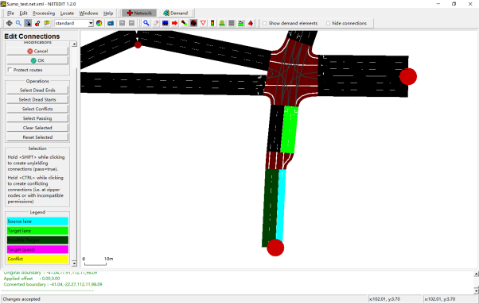

## 修改车道属性：车道宽度、车型等

进入Inspect mode

Shift+左键，选择车道

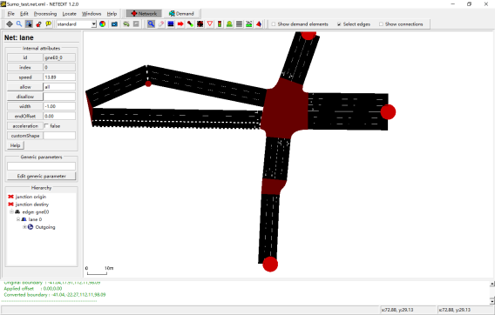

修改车道宽度

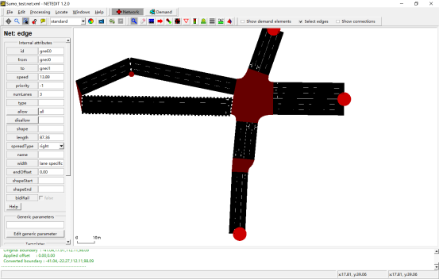

## 添加信号灯

Edit→Network mode

Edit→Traffic light mode

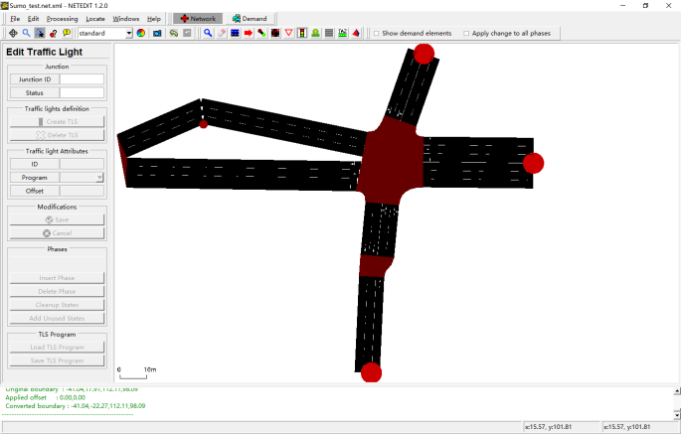

The following signal colors are used:

| **Character** | **GUI Color** | **Description** |
| --- | --- | --- |
| r | FOO | 'red light' for a signal - vehicles must stop |
| y | FOO | 'amber (yellow) light' for a signal - vehicles will start to decelerate if far away from the junction, otherwise they pass |
| g | FOO | 'green light' for a signal, no priority - vehicles may pass the junction if no vehicle uses a higher priorised foe stream, otherwise they decelerate for letting it pass. They always decelerate on approach until they are within the configured [visibility distance](https://sumo.dlr.de/docs/Networks/PlainXML.html" \l "explicitly_setting_which_edge_lane_is_connected_to_which) |
| G | FOO | 'green light' for a signal, priority - vehicles may pass the junction |
| s | FOO | 'green right-turn arrow' requires stopping - vehicles may pass the junction if no vehicle uses a higher priorised foe stream. They always stop before passing. This is only generated for junction type traffic\_light\_right\_on\_red. |
| u | FOO | 'red+yellow light' for a signal, may be used to indicate upcoming green phase but vehicles may not drive yet (shown as orange in the gui) |
| o | FOO | 'off - blinking' signal is switched off, blinking light indicates vehicles have to yield |
| O | FOO | 'off - no signal' signal is switched off, vehicles have the right of way |

创建TLS

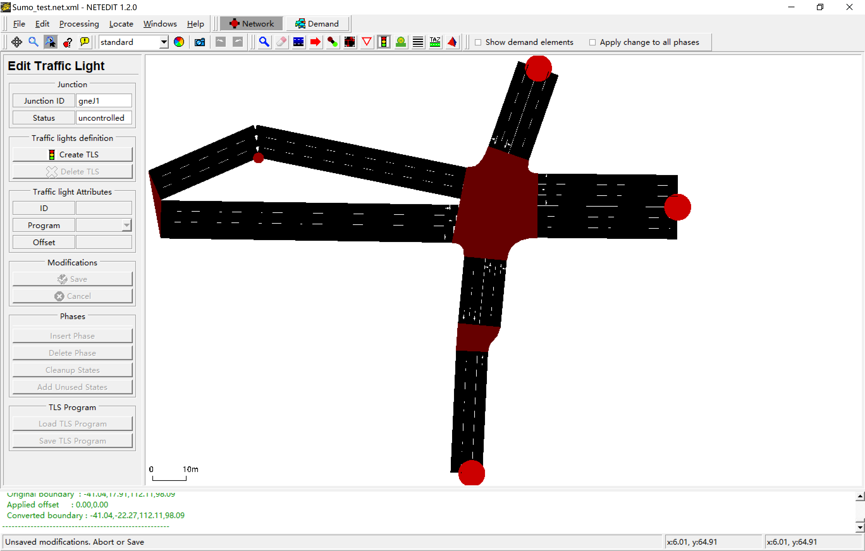

对信号配时方案进行修改

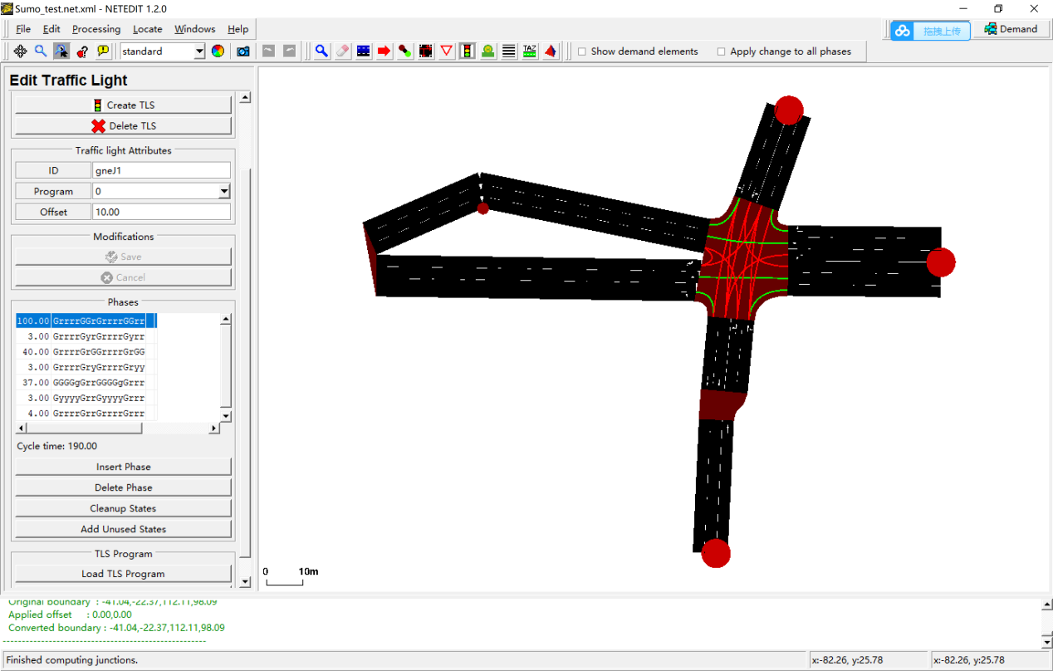

# 按流量和路口转向比例生成车辆路径

## 构造流量配置文件Sumo\_test.flows.xml

<flowdefs>

<flow id="0" from="gneE0" begin="0" end="1" number="100"/>

<flow id="1" from="gneE10" begin="0" end="1" number="100"/>

<flow id="2" from="gneE2" begin="0" end="1" number="100"/>

<flow id="3" from="gneE7" begin="0" end="1" number="100"/>

</flowdefs>

## 构造路段上的转向比例Sumo\_test.turns.xml

<?xml version="1.0" encoding="UTF-8"?>

<turns xmlns:xsi="http://www.w3.org/2001/XMLSchema-instance" xsi:noNamespaceSchemaLocation="http://sumo.dlr.de/xsd/turns\_file.xsd">

<interval begin="0" end="10000">

<fromEdge id="gneE0">

<toEdge id="gneE4" probability=".1"/>

<toEdge id="gneE3" probability=".7"/>

<toEdge id="gneE6" probability=".15"/>

<toEdge id="gneE1" probability=".05"/>

</fromEdge>

<fromEdge id="gneE5">

<toEdge id="gneE3" probability=".2"/>

<toEdge id="gneE6" probability=".5"/>

<toEdge id="gneE1" probability=".3"/>

</fromEdge>

<fromEdge id="gneE2">

<toEdge id="gneE6" probability=".2"/>

<toEdge id="gneE1" probability=".5"/>

<toEdge id="gneE4" probability=".3"/>

</fromEdge>

<fromEdge id="gneE7">

<toEdge id="gneE1" probability=".1"/>

<toEdge id="gneE4" probability=".5"/>

<toEdge id="gneE3" probability=".4"/>

</fromEdge>

</interval>

</turns>

## 用JTRROUTER生成车辆路径文件

### 方法一

call="%SUMO\_HOME%bin\jtrrouter" -n Sumo\_test.net.xml -r Sumo\_test.flows.xml -t Sumo\_test.turns.xml -o Sumo\_test.rou.xml --accept-all-destinations

参见“1.jtrrouter生成rou.bat”文件

### 方法二

构造jtrrcfg文件

生成rou文件，参见“2.jtrrouter生成rou.bat”文件

<?xml version="1.0" encoding="UTF-8"?>

<configuration xmlns:xsi="http://www.w3.org/2001/XMLSchema-instance" xsi:noNamespaceSchemaLocation="http://sumo.dlr.de/xsd/jtrrouterConfiguration.xsd">

<input>

<net-file value="Sumo\_test.net.xml"/>

<route-files value="Sumo\_test.flows.xml"/>

<turn-ratio-files value="Sumo\_test.turns.xml"/>

</input>

<output>

<write-license value="true"/>

<output-file value="Sumo\_test.rou.xml"/>

</output>

<!--

<processing>

<sink-edges value="end"/>

</processing>

-->

<report>

<ignore-errors value="true"/>

<no-step-log value="true"/>

</report>

</configuration>

call="%SUMO\_HOME%bin\jtrrouter" -c Sumo\_test.jtrrcfg --accept-all-destinations

# 构造sumocfg文件

<?xml version="1.0" encoding="UTF-8"?>

<!-- generated on Tue Apr 16 00:19:19 2019 by Eclipse SUMO Version 1.2.0

This data file and the accompanying materials

are made available under the terms of the Eclipse Public License v2.0

which accompanies this distribution, and is available at

http://www.eclipse.org/legal/epl-v20.html

SPDX-License-Identifier: EPL-2.0

-->

<configuration xmlns:xsi="http://www.w3.org/2001/XMLSchema-instance" xsi:noNamespaceSchemaLocation="http://sumo.dlr.de/xsd/sumoConfiguration.xsd">

<input>

<net-file value="input\_net.net.xml"/>

<route-files value="input\_net.rou.xml"/>

</input>

</configuration>

运行该文件即可进行仿真。

# 采集输出数据（sumocfg文件）

添加路段检测器additional\_detect\_params.add.xml

<additional>

<inductionLoop id="myLoop1" lane="gneE0\_1" pos="42" freq="100" file="out.xml"/>

<inductionLoop id="myLoop2" lane="gneE5\_1" pos="10" freq="100" file="out.xml"/>

</additional>

添加输出数据

<output>

<write-license value="true"/>

<queue-output value="output\_queue.xml"/>

<emission-output value="output\_emission"/>

<full-output value="output\_full-output"/>

<vtk-output value="output\_VTK" />

</output>

格式转换：

Python "%SUMO\_HOME%\tools\xml\xml2csv.py" output\_full-output

Python "%SUMO\_HOME%\tools\xml\xml2csv.py" output\_queue.xml

参见“输出数据格式转换.bat”文件。

或者用Excel直接打开察看（需要删除文件中的注释部分）。